***Extraction*** *Of Key Points from Research Papers,* ***Week 1***

*Format : Citation, Key points.*

From these papers our main motive is:

-> Finding gaps in research by looking at models used, their drawbacks, future optimization recommendations by authors and finally something which has not been shed light on.

1)

**[1] S. J. Smith, “EEG in the diagnosis, classification, and management of patients with epilepsy,” J. Neurol. Neurosurg. Psychiatry, vol. 76, no. suppl 2, pp. ii2–ii7, 2005.**

Summary:

| **Syndrome** | **EEG Signature** |
| --- | --- |
| **IGE** | Generalized spike + slow wave (3–5 Hz) |
| **Childhood Absence Epilepsy** | 3 Hz spike-wave lasting 5–10 sec |
| **Juvenile Myoclonic Epilepsy** | Polyspike bursts, often photosensitive |
| **Rolandic Epilepsy** | Centrotemporal spikes (more in sleep) |
| **Landau-Kleffner / ESES** | Continuous spike-wave in sleep |
| **Temporal Lobe Epilepsy** | Anterior/mid-temporal spikes, 5–7 Hz ictal discharge |

**Objective of the Paper :** To evaluate the clinical role of EEG in diagnosing, classifying, and managing epilepsy, especially focusing on the limitations of EEG sensitivity and the importance of interictal discharges (IEDs) in guiding treatment and understanding seizure types

.

* **EEG Sensitivity is Low**: EEG only detects epileptiform activity in 25–56% of patients with epilepsy, especially in short recordings. Therefore, IEDs are critical for detecting seizure risk, especially interictally.
* IEDs Appear in Healthy Individuals:
  + Healthy adults: 0.5%
  + Healthy children: 2–4%
  + Children with neurological conditions: 10–30%  
    ➤ *Children are significantly more likely to show IEDs* — especially with underlying brain injury or developmental issues.
* Timing of EEG Recording Matters:
  + EEG within 24 hours of seizure → 51% IED detection
  + EEG after 24 hours → drops to 34%
  + *IEDs also appear more during sleep*, especially in syndromes like Rolandic Epilepsy.
* Photosensitive Epilepsy:
  + Seen in ~5% of all epilepsies (mostly IGE)
  + 75% of cases are in ages 8–20
  + Triggered by flickering lights; EEG shows photoparoxysmal response

What can be done :

*** I can take data of a patient, check his spikes and check which syndrome is getting more repetitive for patients and maybe based on that I can determine which syndrome is more common among which age group and which region of brain it is specifically targeting

2)

**[1] E. H. Smith, J. Y. Liou, E. M. Merricks, T. Davis, K. Thomson, B. Greger, P. House, R. G. Emerson, R. Goodman, G. M. McKhann, and S. Sheth, "Human interictal epileptiform discharges are bidirectional traveling waves echoing ictal discharges," eLife, vol. 11, p. e73541, Jan. 2022. DOI: 10.7554/eLife.73541.**

Summary:

* Interictal spikes, commonly observed electrical events in epileptic patients, propagate in a similar manner to seizures, which are relatively uncommon and more difficult to capture. This suggests that interictal spikes could be used in surgical planning, improving the localization and treatment of epileptic networks.
* IEDs travel through the brain like waves, often in the same direction (or the opposite) as seizures — and this wave behavior might predict where and how seizures begin.
* Types Of Plots Used: **Raster Plot, Mean Spectrogram**

Final Summary ( We should focus on IEDs and **KLD**s):

Smith et al. (2022) investigated how interictal epileptiform discharges (IEDs), which occur between seizures, might reflect similar propagation patterns as seizure discharges (SDs). Using microelectrode array recordings from 10 epilepsy patients, they found that IEDs behave as bidirectional traveling waves, often echoing seizure pathways but in the reverse direction. Their computational analysis, including Kullback-Leibler Divergence, revealed that IED propagation patterns could predict SD directions, suggesting that IEDs hold potential as early biomarkers for seizure localization and risk modeling. These findings support the use of IEDs as features in predictive models for epileptic seizures

What is KLD??

**Kullback-Leibler Divergence (KLD)** is a statistical tool used to measure how one probability distribution is different from another**.**

**Imagine:**

* You **expect** that IEDs travel in a certain pattern — say, 60% go forward, 40% backward.
* But in actual data (like during a seizure), you observe a **different pattern** — say, 80% go forward, 20% backward.

**KLD tells you how “off” your expectation was.**

Think of it as:  
"How surprised am I if the actual distribution turns out to be different than what I assumed?"

Formula for KLD: ( just for reference)

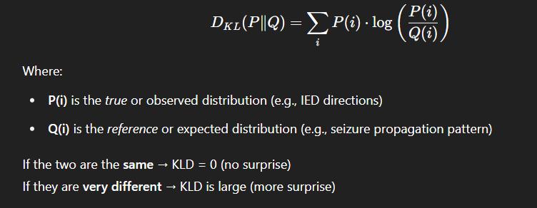

How we can use KLDs:

Researchers look at:

* **IED propagation directions** (during interictal periods)
* **Seizure propagation directions** (during actual seizures)

These are turned into **histograms or distributions**:

* “How many waves went forward, backward, left, right?”

**Then:**

* They calculate **KLD between the IED and SD (seizure discharge) direction distributions**
* **If KLD is low**, that means: *"IEDs are propagating similarly to seizures"*
* ➤ This supports the idea that **IEDs can be used to predict seizure paths or origins**!

**Mentor Suggestion: Matthews correlation coefficient (MCC)**

MCC is a single-score metric that measures the quality of binary classifications, especially when the classes are imbalanced (like seizure vs. non-seizure events). It considers all four parts of a confusion matrix:

* True Positives (TP)
* True Negatives (TN)
* False Positives (FP)
* False Negatives (FN)

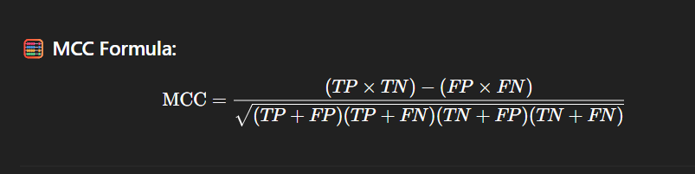

MCC gives 3 values, -1 , 0 and 1 where +1 represents perfect prediction, 0 represents ‘no more than random’ and -1 represents totally incorrect prediction.

How it can help us:

* + We are detecting seizure events from the input data which is also containing many non-seizure events. Now let’s assume seizures are 5% of the data and non-seizures are 95% of data. If model assumes non-seizure for every input, that will make our model useless. Hence MCC is used for catching failure by punishing model for ignoring minority class.
  + We will use MCC along with Accuracy Score, F1 score and confusion matrix.

3)

**[1] H. Albaqami, G. M. Hassan, and A. Datta, “MP-SeizNet: A multi-path CNN Bi-LSTM Network for seizure-type classification using EEG,” *Biomed. Signal Process. Control*, vol. 84, p. 104780, 2023.**

Summary:

-Main objective for this paper was ‘To develop an **automated deep learning model** for **classifying types of epileptic seizures** using EEG data, reducing reliance on neurologists and manual EEG interpretation.’

- They used a multi-path deep learning model combining **CNN i.e. Convolutional Neural Network** ( for time frequency wavelet based feature extraction) and **Bi-LSTM + Attention Mechanism i.e. bi-directional Long Short Term Memory** ( for raw EEG signal learning and temporal dependencies)

-Dataset used: Temple University Hospital EEG Seizure Corpus and focused on **5 seizure types**:

* Absence (ABZ) -> 3 Hz-Spike and wave discharge for 10-20 seconds, causes sudden lapse in consiouness, can be mistaken for daydreaming
* Complex Partial (CPZ) -> Origin- Temporal or frontal lobe (focal onset), causes rhythmic spikes resulting in automatisms like lip smacking or gestures
* Simple Partial (SPZ) -> Focal origin but does not cause loss of consciousness, causes sensory changes and déjà vu feeling. Pattern is Focal spikes or sharp waves of low amplitude.
* Tonic (TNZ) -> Causes muscle stiffness during sleep. Pattern is low voltage fast activity at on-set or even generalized. Can last up to a minute
* Tonic-Clonic (TCZ)-> Causes stiffness followed by jerking. Results in sudden generalized high-frequency spikes ( called as postictal suppression)

-**For CNN, they performed following statistical features- Absolute Mean, Standard deviation, power, kurtosis and skewness and for Bi-LSTM, they fed raw EEG segments directly to Bi-LSTM and used Attention Mechanism for highlighting important time-steps.**

-They received F1 Score of 98% for Seizure-wise 5-fold CV and 88% accuracy for Patient-wise 3 fold CV.

-What we can do:

1)Train the model using Dual-inputs (raw + handcrafted) for better performance and generalization

2) Use wavelet features for capturing spike patterns in EEG

3) Use attention mechanism ( it helps Bi-LSTM to detect subtle seizure features when classes have less data)

4) Perform separate Seizure-wise and Patient-wise model training

Our next plans according to research so far:

**A. Classical Machine Learning Models**

We will establish strong baseline with the handcrafted features like **Absolute Mean, Standard deviation, power, kurtosis and skewness**

1. **Logistic Regression**
2. **Support Vector Machine (SVM)**
3. **Random Forest**
4. **K-Nearest Neighbors (KNN)**
5. **XGBoost**

**B. Deep Learning Models**

We will use raw EEG segments (512×23) directly as input:

1. **1D Convolutional Neural Network (CNN)**
2. **Bidirectional LSTM (Bi-LSTM)**
3. **CNN + LSTM Hybrid**
4. **MP-SeizNet (CNN + Bi-LSTM + Attention)** — this can be used via reference to prev research paper (refer prev page)

**C. Evaluation Metrics for All Models:**

* Accuracy
* F1 Score
* Matthews Correlation Coefficient (MCC)
* Confusion Matrix